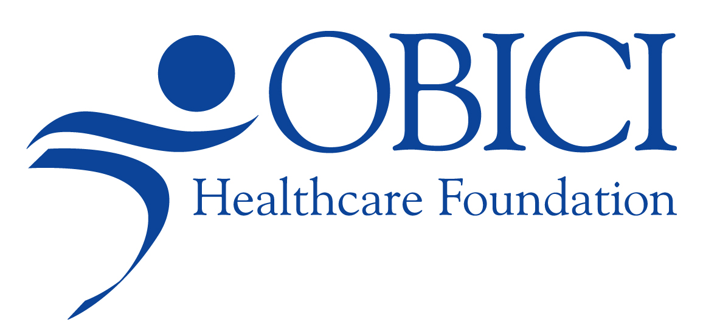
For Immediate Release

Contact:
Diane Nelms
Communications and Program Specialist
Obici Healthcare Foundation
757-539-8810
dnelms@obicihcf.org

Obici Healthcare Foundation Awards $2.2 Million in Grants
(SUFFOLK, VA) May 22, 2015 -- “The Obici Healthcare Foundation is pleased to announce the awarding of over $2.2 million in grants to 21 nonprofit organizations serving Western Tidewater,” said George Y. Birdsong, Foundation Chairman. Award amounts among new and renewed grantees range from $15,000 to $350,000.
“The Foundation Board of Directors and staff are excited by the quality of the programs being offered by this group of grantees committed to providing care in the Foundation’s service area,” Mr. Birdsong added.
The successful Round 16 grantees are listed below by organization names, award amounts, program title and program description:

Eastern Virginia Medical School $45,000 EVMS Continuity of Care for Western Tidewater.
To provide access to basic healthcare to uninsured, Western Tidewater Free Clinic patients by engaging medical residents, third-year medical and physician assistant students.

HumanKind $38,414 Intellectual Disability and Chronic Illness Wellness Program.
To provide Zuni residents with intellectual disabilities with wellness education on healthy eating, physical activity and understanding managing their chronic disease.

Isle of Wight County Department of Social Services $65,796 Enroll Isle of Wight.
To provide uninsured children and families of Isle of Wight County with information, assistance and support outreach to enroll in Medicaid and FAMIS programs.

Isle of Wight County Public Schools $25,000 Learn, Eat, Grow.
To teach elementary-aged school children, in an after-school food club, the importance of growing, preparing, purchasing and eating fresh fruits and vegetables.

Paul D. Camp Community College Foundation $22,755 Improving Nursing Education and Career Access through the Accreditation Commission of Education in Nursing (ACEN).
To improve healthcare delivery through nursing education and career access through the advancement of nursing curriculum and enhanced accreditation.

SCM Vision, Incorporated $50,000 "It's Life Changing" with Dr. Carletta Perry.
To provide viewers of the television program and the YouTube video-sharing website with information about mental health issues and connect them to follow-up services.

Senior Services of Southeastern Virginia $75,000 Medication and Care Access Resource Program. To provide low-income seniors and persons with disabilities in Western Tidewater with outreach services to apply for eligible benefits through Medicare and Medicaid.

Sentara Obici Hospital $141,572 Bridging the Gap in Maternal Infant Home Visiting Services. To provide high-risk expectant families and new parents living of Western Tidewater with case management and home visiting support to increase infant survival rates.

Southeastern Virginia Health System $200,000 Main Street Dental Program.
To provide underserved residents of Suffolk and Western Tidewater with access to comprehensive oral health care services and education at reduced costs.

Suffolk Partnership for a Healthy Community $180,177 Healthy People Healthy Suffolk.
For implementation of a 10-year community wellness plan, Healthy People Healthy Suffolk, that promotes active lifestyles, access to healthy foods, neighborhood engagement and a focus on moving the initiative forward under the framework of striving to make Suffolk a walkable city.

Suffolk Public Schools $100,000 Strategic Health Action and Wellness Plan.
To provide students with resources, such as salad bars and integrating physical activity into core classes, that lead to healthy eating and active living, respectively.

The Planning Council $25,000 Farm to Childcare - Western Tidewater.
To develop a plan to explore ways to bring fresh fruits and vegetables into childcare programs in Western Tidewater by using a Farm to Childcare model.

The Up Center $88,326 Western Tidewater Training and Behavioral Health Program.
To provide individuals and families with trauma informed care and counseling services.

United Way of South Hampton Roads $109,102 Learning and Enrichment for Academic Progress (LEAP). To provide elementary-age Suffolk children participating in 2015 summer school programs with access to oral and behavior health services and improve their health.

Virginia Legal Aid Society $25,000 Triage and Intake Phone System.
To provide clients with a more efficient services by developing an automated telephone triage and intake system.

Virginia Repertory Theatre $15,000 Childhood Obesity Prevention.
To develop an elementary school-aged play to both educate and entertain children with a solid message for obesity prevention.

Voices for Kids CASA Program $25,000 Expanding Advocacy for Children with Medical and Mental Health Needs.
To provide abused and neglected children of Suffolk with access to medical, dental and mental health services through court-appointed special advocate volunteer program.

VOLUNTEER Hampton Roads $30,000 Service Enterprise Initiative
To benefit the communities they serve, three nonprofit organizations will be engaged in a one-year program to increased effectiveness and efficiencies in their volunteer operations.
Western Tidewater Community Services Board $24,064 Telemedicine - Crisis Services
Follow-up. To provide residents of Western Tidewater with mental health telemedicine crisis services support that will connect them to the appropriate community program and improve the time it takes to connect to a provider.

Western Tidewater Community Services Board $123,770 Whole Health Action Management.
To provide the seriously mentally ill (SMI) population in Western Tidewater with trained peer providers who will educate, monitor and assist with their chronic disease management to individuals enrolled.

Western Tidewater Community Services Board $357,859 Shared Psychiatric Services.
To provide uninsured and under insured adults with access to community-based psychiatric services for behavioral health care that is necessary in order to maintain their stability in the community.

Western Tidewater Community Services Board $145,648 Mobile Crisis Outreach
To provide Western Tidewater residents with integrated outpatient counseling by trained clinical staff at local shelters, community health centers and clinics.

Western Tidewater Health District $140,422 Nurse Family Partnership Program.
To improve the reduction of undesirable birth outcomes among first-time pregnant mothers through education, nurse case management, home visitation and transportation assistance.

YMCA of South Hampton Roads $74,475 Diabetes Prevention Program.
To help pre-type 2 diabetics prevent or delay the onset of the disease through a one-year education program, increased physical activity and long-term behavior change.

“Grants made by the Foundation continue Amedeo Obici’s legacy of improving the health status of people living in the service area,” noted Gina Pitrone, Foundation Executive Director. “Mr. Obici, the founder of Planter’s Peanuts, was successful in business and passionate about helping the people in Western Tidewater and Gates County, NC.”
# # #

About the Obici Healthcare Foundation: This private foundation was created in 2006 with assets established through the generosity of Mr. Obici and funds from the merger of Louise Obici Memorial Hospital and Sentara Healthcare. Since its inception, the Foundation has awarded over $33 million in grant funding.

